**SAFE WORK MONTH**

**The bulletin will seek to:**

* Raise an awareness of workers and PCBUs responsibilities with regard to general safety within the workplace.
* Invite workers to raise safety issues that they perceive as a concern.

**Principles:**

October is National Safe Work Month - a time to commit to building a safe and healthy workplace.

Being healthy and safe means being free from physical and psychological harm. No job should be unsafe and no death or injury is acceptable. A safe and healthy workplace benefits everyone.

The theme for National Safe Work Month this year is **think safe. work safe. be safe.**

This October **think safe. work safe. be safe.** at your workplace by planning and implementing work health and safety procedures

**Stay Vigilant! Be watchful, Staying healthy and safe at work, Don’t get hurt.**

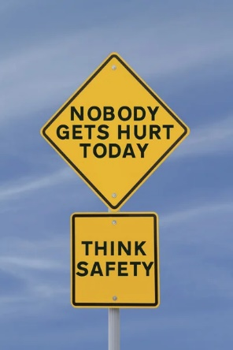

**EVERY PERSON HAS A RESPONSIBILITY TO KEEP THEMSELVES AND OTHERS AS SAFE AS POSSIBLE.**

Hazards exist in all workplaces, with some hazards more obvious than others but remember that not all hazards are obvious. Workplaces try to keep you safe by implementing various controls. These assist in protecting workers from workplace hazards in order to:

* Avoid Injuries.
* Illnesses and incidents.
* Reduce Health and Safety risks.
* Provide Safe and Healthy working conditions.

**Never take shortcuts:** Discussions and regular assessments are conducted to ensure safety systems are up to date which for example like:

* Inductions and training.
* Signage.
* Safety policies procedures TBT.

Are put in to place for everyone’s safety.

**No matter your job its always important to improve your health and safety at your work place.**

* Always listen carefully to what is said in Toolbox talks
* Follow training provided
* Understand and identified hazards and follow safe work practices.
* Wear PPE as required.
* Act in a safe manner at all times.
* Follow all safe work practices agreed for your site.
* Always report any safety concerns.

Remember WHS is for everyone’s Health and wellbeing improves productivity and quality of work

**Safety is in your hands!**